**Unique Science Academy, 60 – D Nawab Town, Lahore**

**Statistics 12 Monthly Test**

(Chapter 10 – Normal Distribution – Objective Type)

29 August 2024 Allowed Time: 50 minutes

Total Marks: 50

**Name ____________________________________**

**1. Select all that are true. (1 x 40 = 40)**

1. The normal distribution is a _______________ that ranges form _____________.

* Discrete probability distribution, $-∞$ to $+∞$
* Continuous probability distribution, $0$ to $1$.
* Continuous frequency distribution, $-1$ to $+1$
* Continuous probability distribution, $-∞$ to $+∞$

1. The value of the parameter $σ$ of a standard normal distribution is always ______.

* Positive
* Negative
* 1
* Can be positive and negative

1. The normal distribution is a bell shaped ___________ distribution.

* Skew – Symmetrical
* Symmetrical
* No skewed
* Positively and Negatively Skewed

1. If $X\sim N\left(50,25\right)$, then $μ=_______$ and $σ= _______$

* $50$ and $25$
* $50$ and $\sqrt{25}$
* $0$ and $1$
* $50$ and $5$

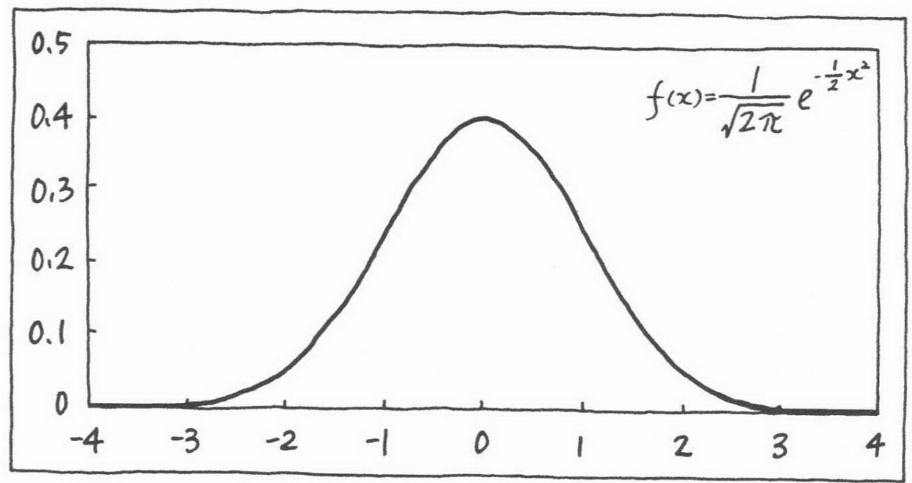

1. The maximum ordinate of the standard normal curve is at $Z=$

$μ$

$σ$

$0.39$

$0$

______
2. The maximum ordinate of the normal curve is at $X= ________$

* Mode

$μ$

$σ$

$+∞$

1. The total area under a normal curve is _________

* Unity

$1$

$100\%$

$∞$

1. The _______ of a normal distribution corresponds to $z=0$ in the standard normal distribution.

* Mean
* Median
* Mode

$σ$

1. In a normal distribution, the mean, median and mode are __________.

* Same
* Identical
* Equal
* Can be different

1. In a standard normal distribution, if $P\left(Z<z_{0,975}\right)=0.975$, then $z_{0.975}= _______$

* 0.975
* 0.025
* 1.96
* 97.5%

1. In a normal distribution, $=μ-0.6745 σ$

$Q_{1}$

$z_{0.25}$

$Φ^{-1}\left(0.25\right)$

$P_{25}$

__________________
2. In a normal distribution, $=μ+0.6745 σ$

$Q_{3}$

$z_{0.75}$

$Φ^{-1}\left(0.75\right)$

$P_{75}$

__________________
3. In a normal distribution, Quartile Deviation $≈$ $σ$

$0.6745$

$2/3$

$0.7979$

$4/5$

_______
4. In a normal distribution, Mean Deviation $≈$ $σ$

$4/5$

$0.7979$

$\sqrt{2/π}$

$0.6745$

_________
5. In a normal distribution, all odd order moments about mean are _______.

* Positive
* Negative
* Zero
* Additive identity of Real Numbers

1. In a normal distribution, $β_{1}=______$ and $β_{2}= _________$.

* $0$, $0$
* $3$, $0$
* $0$, $3$
* $3$, $3$

1. The normal distribution is ____________.

* Platykurtic
* Mesokurtic
* Leptokurtic
* Symmetrical

1. The points of inflexion of a normal curve are _______ from mean.

* Equidistant
* Having different distance
* Skewed
* Zero

1. The limits $μ±σ$ include ________ percent area under the normal curve.

* 68.27
* 95.45
* 99.73
* 68.45

1. The limits $μ±2σ$ include ________ percent area under the normal curve.

* 68.27
* 95.45
* 99.73
* 68.45

1. The limits $μ±3σ$ include ________ percent area under the normal curve.

* 68.27
* 99.45
* 99.73
* 68.45

1. The limits $μ±0.6745σ$ include _______ percent area under the normal curve.

* 25
* 50
* 75
* 100

1. Normal distribution has two parameters namely _____ and ______.

* Mean, Standard Deviation
$μ, σ^{2}$

$μ, σ$

* Mean, Variance

1. If $X$ is normally distributed with mean $μ$ and variance $σ^{2}$, then it is denoted by
$X\sim N\left(μ,σ\right)$

$X\sim N\left(0,1\right)$

$X\sim N\left(μ,σ^{2}\right)$

$Z\sim \left(μ,σ\right)$

2. The standard normal distribution has mean ____ and variance _____.

* 0, 1
* 1, 0
* $μ$, $σ$
* 0, 0

1. Which of the following statement is NOT correct about maximum ordinate of a standard normal curve?

* The maximum ordinate of a standard normal curve is approximately 0.3989
* The maximum ordinal of a standard normal curve is at $Z=μ$
* The maximum ordinate of a standard normal curve is at $Z=1$
* The maximum ordinate of a standard normal curve is at $Z=0$

1. The standard normal distribution is symmetrical about _____.
$Z=μ$

$Z=0$

$Z=μ±σ$

$μ-σ<Z<μ+σ$

2. The normal curve has maximum ordinate at
$X=0$

$X=1$

$X=μ$

$X→∞$

3. In a standard normal distribution, if $P\left(\left|Z\right|<a\right)=0.95$, then $a= ________$.

* -1.96
* 1.96

$Φ^{-1}\left(0.95\right)$

$2Φ^{-1}\left(0.95\right)-1$

1. In a standard normal distribution, if $P\left(Z<z_{0.025}\right)=0.025$, then $z_{0.025}=______$.

* -1.96
* 1.96

$Φ^{-1}\left(0.025\right)$

$1-Φ^{-1}\left(0.95\right)$

1. In a standard normal distribution, if $P\left(Z<z_{0.975}\right)=0.975$, then $z_{0.975}=______$.

* -1.96
* 1.96
$1.645$

* -1.645

1. The normal curve gets closer and closer to the $x$- axis but never touches it. This property of normal distribution is known as:

* Symmetrical
* Asymmetrical
* Asymptotic
* Invariant

1. The expected value of a normal distribution is

* Mean
* Median
* Mode
* Variance

1. The shape of a normal distribution depends upon ________.

* Ordinates
* Area
* Parameters

$\sqrt{2π}$

1. The second moment about mean of the normal distribution is

$σ$



$σ^{2}$



$3σ^{4}$



$μ^{2}$

 _____
2. In a normal distribution:

* Mean and variance are always equal
* Variance can be zero.

$P\left(μ-σ<X<μ+σ\right)=P\left(-1<Z<+1\right)$

$P\left(μ-2σ<X<μ+2σ\right)=P\left(-2<Z<+2\right)$

1. The parameter $σ$ controls the __________ of the normal curve.

* Location on $x$- axis
* Relative flatness
* Origin
* Symmetry

1. In a normal distribution, all even moments about mean are ____.

* Zero
* Negative
* Positive
* Same

1. The points of inflexion of the normal curve lie at ______.
$μ±σ$

$μ±2σ$

$μ±3σ$

$μ^{2}±2σ^{2}$

2. Fourth moment about mean in a normal distribution is _______.

$σ^{2}$

* 3

$3σ^{4}$

$3σ^{2}$

**Mathematical / Theoretical Part**

1. **Match the correct statements. (2 x 4 = 8)**

|  |  |
| --- | --- |
| **Function Name** | **Function** |
| Normal Probability Density Function $p.d.f$ | $$F\left(x\right)=P\left(X≤x\right)=P\left(-∞<X≤x\right)$$ |
| Normal Cumulative Distribution Function $c.d.f$ | $$φ\left(z\right)=\frac{1}{\sqrt{2π}}e^{-\frac{z^{2}}{2}}$$ |
| Standard Normal Probability Density Function | $$Φ\left(z\right)=P\left(Z≤z\right)=P\left(-∞<Z≤z\right)$$ |
| Standard Normal Cumulative Distribution Function | $$f\left(x\right)=\frac{1}{σ\sqrt{2π}}e^{-\frac{1}{2}{\left(\frac{x-μ}{σ}\right)}^{2}}$$ |

1. **Select all correct options (1 x 2 = 2)**
2. Which table is used for finding the value $Φ\left(1.96\right)$?

* Ordinates of the Standard Normal Curve at $Z=z$
* Quantiles of the Standard Normal Distribution
* Values of the Normal Cumulative Distribution Function
* Values of the Standard Normal Cumulative Distribution Function

1. Which table is used for finding the value $Φ^{-1}\left(0.95\right)$?

* Ordinates of the Standard Normal Curve at $Z=z$
* Quantiles of the Standard Normal Distribution
* Inverse Standard Normal Cumulative Distribution Function
* Values of the Standard Normal Cumulative Distribution Function